Water Service Line Survey
To comply with EPA regulations, public water systems are required to complete an inventory of service lines, and this survey plays a vital role in helping your public water system fulfill this obligation effectively. The following information will help you determine where your water service line is and what material the line is made of.

Find Your Water Service Line
Before completing the survey, you need to determine where the water service line is and how it connects to your home.

Outside Meter or Curb Stop
To locate where the water service line enters your home, look for a water meter box. These are usually found at the front of your property near the street or sidewalk and are ground-level boxes labeled "water" or "meter." Once you find them, follow the shortest path to your home. The water service line usually enters the building through the floor or foundation wall in this general area.

Test the Pipe Material
Once you've found where the water service line enters your home, look for a spot on the pipe closest to the wall or floor before it connects to a valve or meter. At this spot, you can test the material the pipe is made of.

Testing Tools
Use the following tools to determine the type of pipe material the water service line is made of.
- Refrigerator magnet—use to test if the pipe is made of steel.
- Coin or key—use to scratch the pipe to reveal the metal’s color and hardness.
- Flashlight or mobile phone—light to clearly see the pipe.
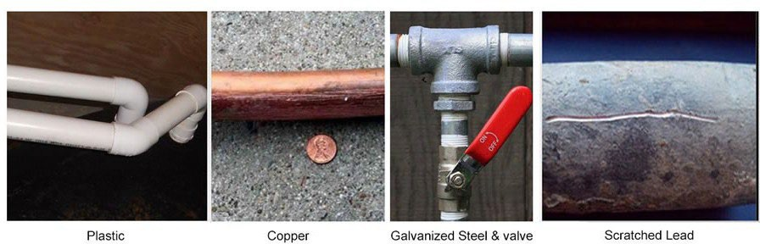

Plastic—This pipe comes in different materials and colors. If you tap it with a coin, the pipe does not make a ringing sound.
Copper—Scratch the pipe and it appears orange and shiny like a penny, which means the pipe is made of copper. Additionally, a magnet will not stick to it.
Galvanized Steel or Iron—The pipe appears silvery gray and is difficult to scratch and a magnet sticks on it. The pipe is made of galvanized steel or galvanized iron.
Lead—The pipe is silvery gray and (1) is easily scratched, (2) the metal seems soft, and (3) a magnet does not stick to it—likely lead pipe.

Water Line Service Survey

(fillable form is located on our website under forms and reports)

Location Information:
Address:
City: | Zip Code:

Please answer the following questions:

Do you own or rent this building? |  | ☐ Own |  | ☐ Rent
What year was the building built?
To your knowledge, has the water service line for your building ever been replaced?
☐ Yes | What year was it replaced?
☐ No
☐ Not sure
What material is your water service line? You may choose more than one.
☐ Lead |  |  | ☐ Copper
☐ Steel (ductile iron pipe, galvanized) |  |  | ☐ Plastic (HDPE, PVC)
☐ Unknown (Call the office) |  |  | ☐ Cannot locate service line
How did you determine the material? Choose one.
☐ Scratch test |  |  | ☐ Visual
☐ Cannot locate service line |  |  | ☐ Plumber or other qualified professional
District representatives will be working on meter inspections and may need access to your property. The representative will knock on your door or otherwise contact you prior to entering your property.

Please return your survey to the following address: For your convenience, you can include it with your next utility payment or email it to southsidewaterandsewer@swsdidaho.org.

Southside Water & Sewer
PO Box D
Sandpoint, ID 83864

